Exercise 2 Date:
Develop and compare CLI, GUI, and Voice User Interfaces (VUI) for the same task and assess user satisfaction using Python (Tkinter for GUI, Speech Recognition for VUI), Terminal
AIM:
The aim is to develop and compare Command Line Interface (CLI), Graphical User Interface (GUI), and Voice User Interface (VUI) for the same task, and assess user satisfaction using Python (with Tkinter for GUI and Speech Recognition for VUI) and Terminal.
PROCEDURE:
i) CLI (Command Line Interface)
CLI implementation where users can add, view, and remove students.
students = []
def add_student(name):
students.append(name)
print(f"Student '{name}' added successfully.")
def view_students():
if students:
print("\n📋 Student List:")
for idx, student in enumerate(students, 1):
print(f"{idx}. {student}")
else:
print("No students found.")
def remove_student(number):
if 0 < number <= len(students):
removed = students.pop(number - 1)
print(f"Student '{removed}' removed successfully.")
else:
print("Invalid number.")
def main():
while True:
print("\n===== Student Management System =====")
print("1. Add Student")
print("2. View Students")
print("3. Remove Student")
print("4. Exit")

choice = input("Enter your choice (1-4): ")
if choice == '1':
name = input("Enter student name: ")
add_student(name)
elif choice == '2':
view_students()
elif choice == '3':
try:
num = int(input("Enter student number to remove: "))
remove_student(num)
except ValueError:
print("Please enter a valid number.")
elif choice == '4':
print("Exiting program...")
break
else:
print("Invalid choice. Please try again.")

if __name__ == "__main__":
main()

Sample Output:
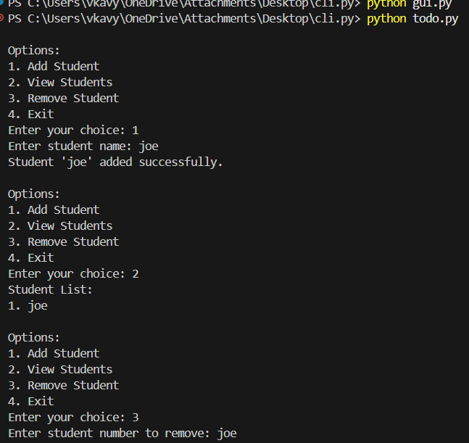
ii) GUI (Graphical User Interface)
Tkinter to create a simple GUI for our To-Do List application.
import tkinter as tk
from tkinter import messagebox
goals = []
def add_goal():
text = entry.get()
if text:
goals.append(text)
listbox.insert(tk.END, text)
entry.delete(0, tk.END)
else:
messagebox.showwarning("Warning", "Enter a goal!")
def remove_goal():
selected = listbox.curselection()
if selected:
listbox.delete(selected)
goals.pop(selected[0])
root = tk.Tk()
root.title("Simple Goal Tracker")
root.geometry("300x350")
entry = tk.Entry(root, width=30)
entry.pack(pady=10)
tk.Button(root, text="Add Goal", command=add_goal).pack(pady=5)
tk.Button(root, text="Remove Goal", command=remove_goal).pack(pady=5)

listbox = tk.Listbox(root, width=35, height=10)
listbox.pack(pady=10)
root.mainloop()

Sample Output:
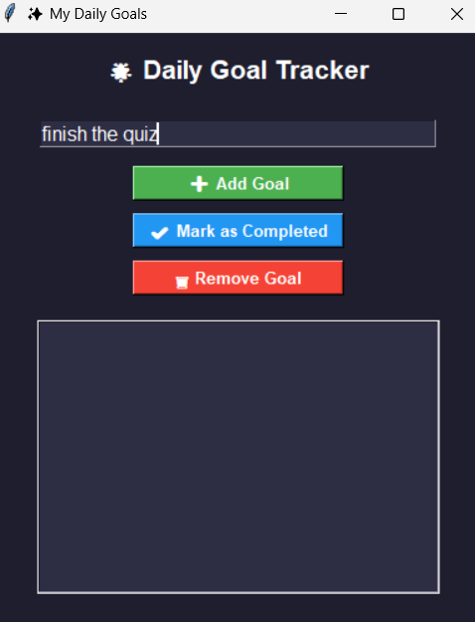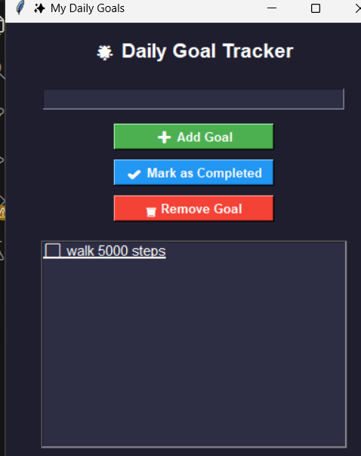
iii) VUI (Voice User Interface)
speech_recognition library for voice input and the pyttsx3 library for text-to-speech output. Make sure you have these libraries installed (pip install SpeechRecognition pyttsx3).
import speech_recognition as sr
import pyttsx3
tasks = []
recognizer = sr.Recognizer()
engine = pyttsx3.init()
def add_task(task):
tasks.append(task)
engine.say(f"Task {task} added")
engine.runAndWait()
def view_tasks():
if tasks:
engine.say("Your tasks are")
for task in tasks:
engine.say(task)
else:
engine.say("No tasks to show")
engine.runAndWait()
def remove_task(task_number):
if 0 < task_number <= len(tasks):
removed_task = tasks.pop(task_number - 1)
engine.say(f"Task {removed_task} removed")
else:
engine.say("Invalid task number")
engine.runAndWait()
def recognize_speech():
with sr.Microphone() as source:
print("Listening...")
audio = recognizer.listen(source)
try:
command = recognizer.recognize_google(audio)
return command
except sr.UnknownValueError:
engine.say("Sorry, I did not understand that") engine.runAndWait()
return None
def main():
while True:
engine.say("Options: add task, view tasks, remove task, or exit")
engine.runAndWait()
command = recognize_speech()
if not command:
continue
if "add task" in command:
engine.say("What is the task?")
engine.runAndWait()
task = recognize_speech()
if task:
add_task(task)
elif "view tasks" in command:
view_tasks()
elif "remove task" in command:
engine.say("Which task number to remove?")
engine.runAndWait()
task_number = recognize_speech()
if task_number:
remove_task(int(task_number))
elif "exit" in command:
engine.say("Exiting...")
engine.runAndWait()
break
else:
engine.say("Invalid option. Please try again.")
engine.runAndWait()
if name == " main ":
main()
Sample Output:
